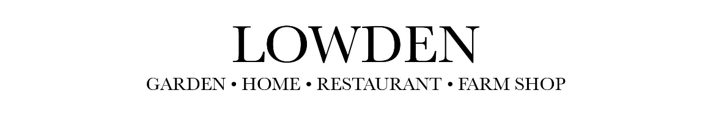
Lowden Christmas Market
www.lowdengardencentre.com

Application Form for The Lowden Christmas Market in Aid of Dorothy House Hospice Care
Friday 13th November 6pm-8pm
Saturday 14th November 10am-4pm
Sunday 15th November 10am-4pm

Name, Company & Address:
Contact Tel: Emergency Contact Tel:
Email Address:
Type of Business/Product Description:

I can confirm that I have public liability insurance and attach a copy
Signed:
Date:
Raffle prize donation:
Number of chairs:
Power: YES/NO

Pitch Fee: £50 per table plus raffle prize donation in aid of Dorothy House Hospice Care,
we will ask for payment if your application is successful.

All applications must include a copy of your public liability insurance.
Please return this form to Eloise Middleton, Lowden Garden Centre, Bath Road, Shaw, Melksham, SN12 8EZ or email hello@lowdengardencentre.com

Thank you.

